**Title:** Rate My Professor Real Life Gender Bias Examples

**Type of Activity:** Small group discussion

**Time Required:** 10-15 mins.

**Learning Outcome Applied:** Recognize and identify real life examples of overt and subtle gender bias in STEM

**Overview:** This learning activity uses the [gendered language in teaching reviews](https://benschmidt.org/profGender/#%7B%22database%22%3A%22RMP%22%2C%22plotType%22%3A%22pointchart%22%2C%22method%22%3A%22return_json%22%2C%22search_limits%22%3A%7B%22word%22%3A%5B%22his%20kids%22%2C%22her%20kids%22%5D%2C%22department__id%22%3A%7B%22%24lte%22%3A25%7D%7D%2C%22aesthetic%22%3A%7B%22x%22%3A%22WordsPerMillion%22%2C%22y%22%3A%22department%22%2C%22color%22%3A%22gender%22%7D%2C%22counttype%22%3A%5B%22WordCount%22%2C%22TotalWords%22%5D%2C%22groups%22%3A%5B%22unigram%22%5D%2C%22testGroup%22%3A%22C%22%7D) website to prompt students to think about how gender stereotypes affect reviews on Rate My Professor. It asks students to view screenshot examples of Rate My Professor reviews for their discipline and to reflect on how those reviews can potentially display gender bias. This learning activity is mentioned in the content video[add link later] provided for more information. All questions within this activity are suggestions so feel free to skip around or add any questions of your own that come up during your discussion.

**Step 1:** Open up [Gendered Language in Teaching Reviews](https://benschmidt.org/profGender/#%7B%22database%22%3A%22RMP%22%2C%22plotType%22%3A%22pointchart%22%2C%22method%22%3A%22return_json%22%2C%22search_limits%22%3A%7B%22word%22%3A%5B%22his%20kids%22%2C%22her%20kids%22%5D%2C%22department__id%22%3A%7B%22%24lte%22%3A25%7D%7D%2C%22aesthetic%22%3A%7B%22x%22%3A%22WordsPerMillion%22%2C%22y%22%3A%22department%22%2C%22color%22%3A%22gender%22%7D%2C%22counttype%22%3A%5B%22WordCount%22%2C%22TotalWords%22%5D%2C%22groups%22%3A%5B%22unigram%22%5D%2C%22testGroup%22%3A%22C%22%7D) website

**Step 2:** Before showing the examples of gender bias make sure to stress to the students that language showcasing gender bias is not done intentionally because stereotypes are activated automatically and done so effortlessly.

**Step 3:** Pick out screenshots of rate my professor reviews for your discipline to discuss with students

**Step 4:** As you show students these screenshots ask them some of the following questions

1. What words in this Rate My Professor review do you believe are gendered? (plug in the words students share into the website to either confirm or deny)
2. What stereotypes about men or women do these words represent?
3. What is your own experience with Rate My Professor? Do you use it when choosing classes and if so, have you found them to be too harsh?

**Biology**

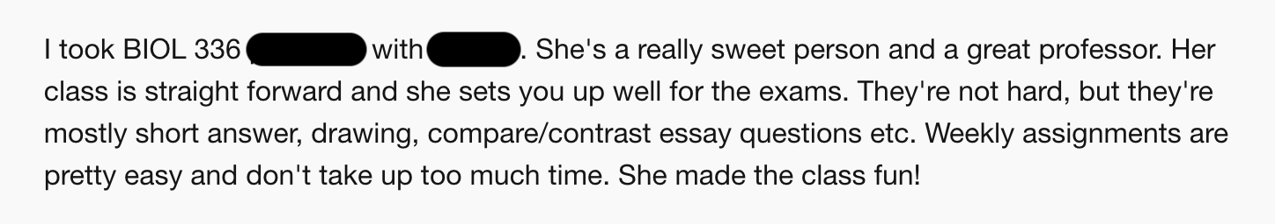

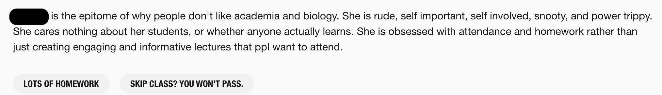

**Chemistry**

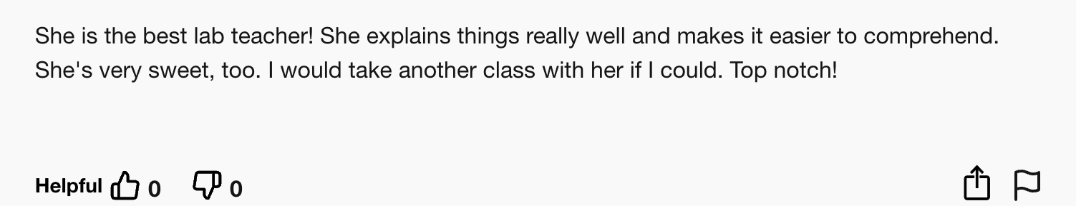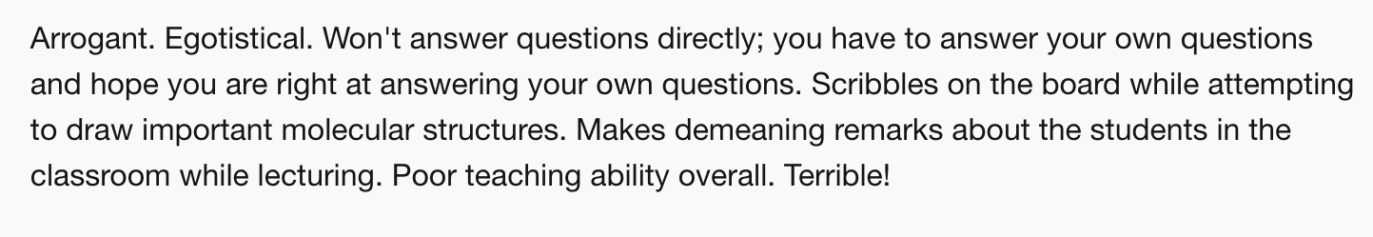

**Computer Science**

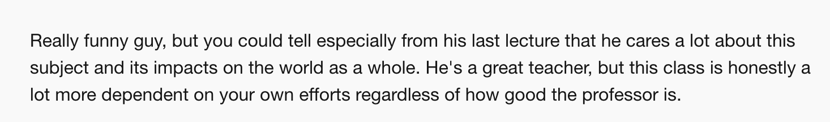

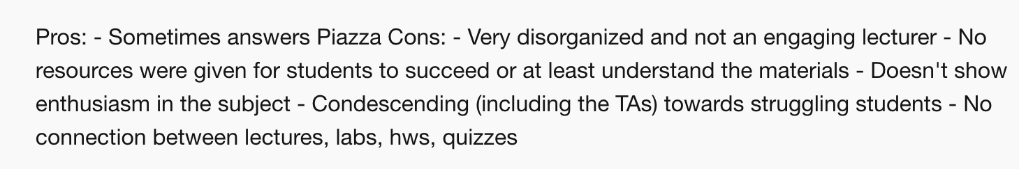

**Engineering**

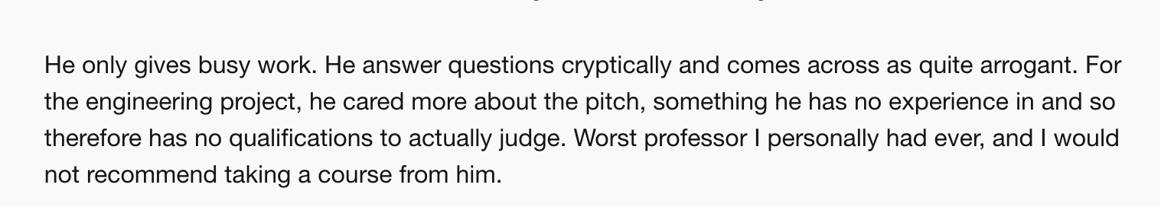

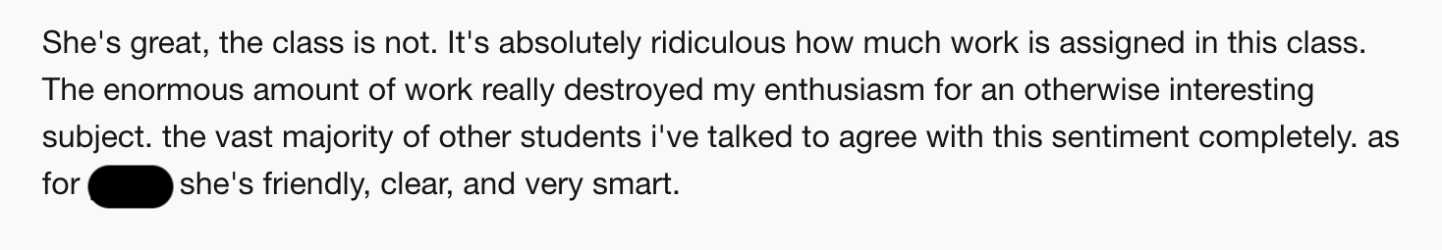

**Math**

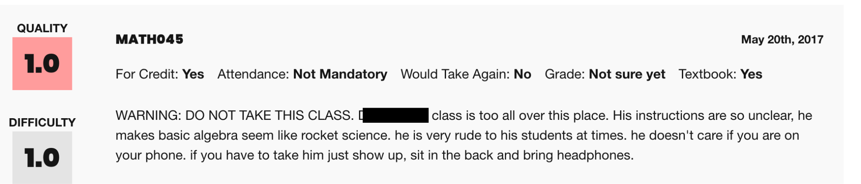

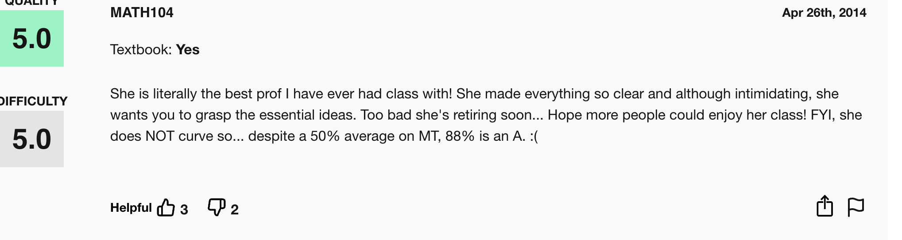

**Physics/Astronomy**

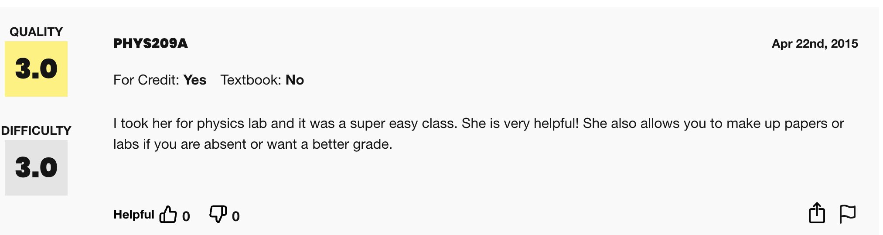

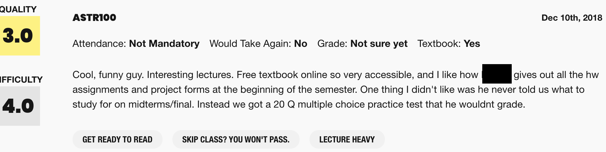

**Statistics**

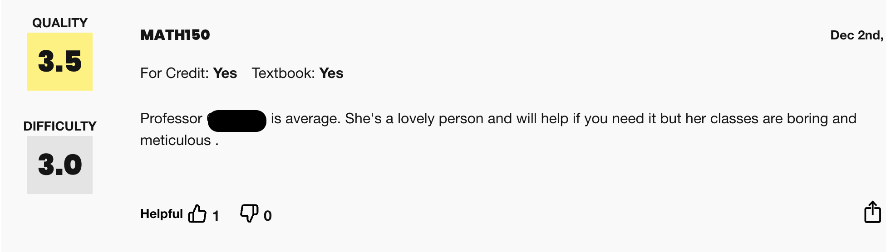

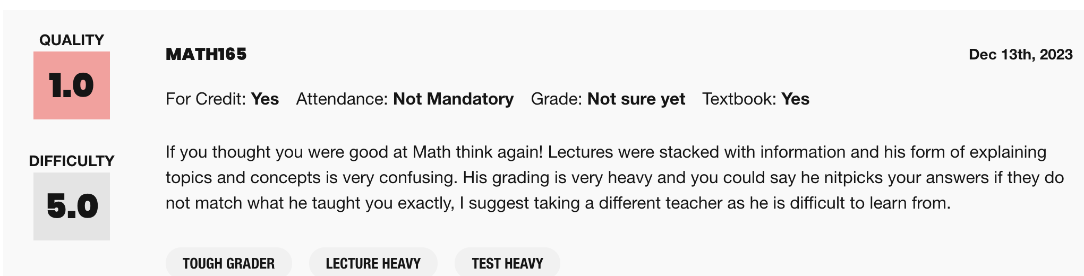

Here are some examples of more gendered terms that come up in Rate My Professor reviews:

* **Disorganized/organized**
* **Nice/sweet**
* **Intelligent/brilliant**
* **Mean/rude**
* **Helpful**
* **Funny**